Introduction to Android & Kotlin

1. Overview
- Android powers over 70% of global smartphones, giving developers the widest user reach.
- Kotlin is the official and preferred language for Android development, backed by Google.
- It offers cleaner and more concise syntax, reducing the amount of code needed.
- Features like null-safety, data classes, extension functions, and coroutines help prevent errors and improve performance.
- Kotlin enables faster, more efficient, and more stable app development.
- It is easy to learn, making it suitable for beginners entering mobile development.
- Strong support from Google, JetBrains, and the developer community ensures long-term relevance.
- Widely used by major companies such as Google, Netflix, Uber, and Pinterest, making Kotlin skills highly employable.
- Kotlin works beyond Android, supporting backend, web, and cross-platform development, providing future-proof opportunities.

1. Overview of Android OS
- Definition: Android is an open-source mobile operating system developed by Google and based on the Linux kernel.
- History: First released in 2008; now the world’s most used mobile OS.
- Features:
  - Open-source and customizable
  - Multi-tasking support
  - User-friendly interface
  - Google integration (Gmail, Maps, Play Store, etc.)
  - Rich app ecosystem (over 3 million apps)
- Importance in Industry: Powers smartphones, tablets, smart TVs, wearables, and IoT devices.

2. The Android Ecosystem
The Android ecosystem represents the entire environment supporting Android devices and apps.
Key Components:
- Devices: Smartphones, tablets, TVs, watches, car infotainment systems.
- Software: Android OS, Google Play Store, and Google Play Services.
- Development Tools:
  - Android Studio: Official IDE for development
  - SDK (Software Development Kit): Tools and libraries for app creation
  - AVD (Android Virtual Device): Emulator for testing apps
- Languages Used: Kotlin (official), Java, and sometimes C++
- Support Services: Firebase for backend, cloud storage, analytics, and notifications.

3. Android Architecture
Android’s architecture is divided into several key layers that interact with each other:
Layer | Description
Applications | User-installed and system apps (Contacts, Messages, Games, etc.)
Application Framework | Provides APIs for developers (Activities, Content Providers, Notifications)
Libraries & Android Runtime (ART) | Includes core libraries and runtime for executing apps
Linux Kernel | Handles device hardware, drivers, memory, and process management

Diagram (conceptual):

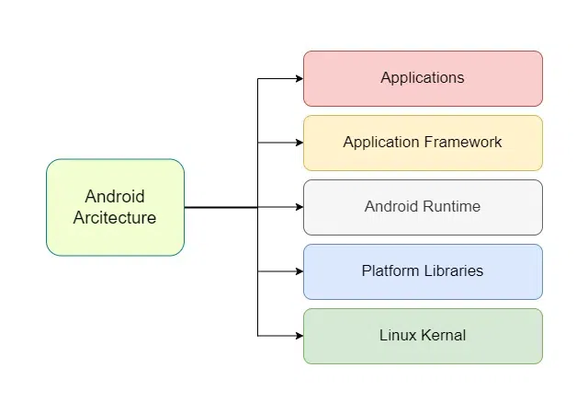
4. Introduction to Kotlin
Kotlin is a modern, statically-typed programming language officially supported by Google for Android development.
Key Features:
- Concise and expressive syntax
- Null safety to prevent app crashes
- 100% interoperability with Java
- Supports object-oriented and functional programming
- Easier to maintain and debug

Example:
fun main() {
val name = "Android Developer"
println("Welcome, $name!")
}

Why Kotlin for Android?
- Officially supported by Google since 2017
- Improves productivity and reduces boilerplate code
- Integrates smoothly with existing Java projects

5. Android Development Environment
To start Android development, developers need:
- Android Studio: IDE for building, testing, and debugging Android apps
- Java Development Kit (JDK): Required for compiling Kotlin/Java code
- Android SDK Tools: Provides necessary APIs
- Emulator/Device: For testing apps

Steps to Set Up:
- Install Android Studio
- Configure SDK and Virtual Device
- Create a new project
- Write code in Kotlin
- Run the app on an emulator or connected device

6. Creating Your First Android App (Optional Demo Subtopic)
Steps:
- Open Android Studio → Start a new project
- Select template (Empty Activity)
- Choose language → Kotlin
- Set package name and location
- Click Finish to generate project files
- Run the app → “Hello World!” on emulator

Files Created:
- MainActivity.kt → Main Kotlin file
- activity_main.xml → UI layout
- AndroidManifest.xml → App configuration
- gradle.build → Build configuration

Trainer reference:

Essential Topics to Include in This Unit
Category | Topics
Android Fundamentals | What is Android, Architecture, Features, Ecosystem
Kotlin Programming Basics | Syntax, Variables, Data Types, Functions, Classes
Development Setup | Android Studio installation, SDK setup, Emulator
First App Creation | Project structure, Writing first code, Running app
Practical Understanding | Debugging, Logcat usage, Understanding XML layouts
Integration | How Kotlin works with Android components

Learning Outcomes
By the end of this topic, students will be able to:
- Explain the structure and features of the Android OS.
- Understand Android’s layered architecture.
- Describe the role of Android Studio and SDK tools.
- Write and execute basic Kotlin programs.
- Create and run a simple Android application.

